**ENHANCING CONVERSATIONAL AI MODEL PERFORMANCE AND EXPLAINABILITY FOR SINHALA-ENGLISH BILINGUAL SPEAKERS**

2022-056

Project Status Document - I

Dissanayake D.M.I.M.

(Hameed M.S., Jayasinghe D.T., Sakalasooriya S.A.H.A.)

B.Sc. (Hons) Degree in Information Technology Specialising in Data Science

Department of Information Technology

Sri Lanka Institute of Information Technology

Sri Lanka

May 2022

**ENHANCING CONVERSATIONAL AI MODEL PERFORMANCE AND EXPLAINABILITY FOR SINHALA-ENGLISH BILINGUAL SPEAKERS**

2022-056

Project Status Document - I

B.Sc. (Hons) Degree in Information Technology Specialising in Data Science

Department of Information Technology

Sri Lanka Institute of Information Technology

Sri Lanka

May 2022

# Declaration, Copyright Statement

We declare that this is our own work, and this project status document does not incorporate without acknowledgement any material previously submitted for a degree or diploma in any other university or Institute of higher learning and to the best of our knowledge and belief it does not contain any material previously published or written by another person except where the acknowledgement is made in the text.

|  |  |  |
| --- | --- | --- |
| **Name** | **Student ID** | **A picture containing text  Description automatically generatedSignature** |
| Dissanayake D.M.I.M. | IT19069432 |  |
| Hameed M.S. | IT19064932 |  |
| Jayasinghe D.T. | IT19075754 |  |
| Sakalasooriya S.A.H.A. | IT19051208 |  |

# **Table of Contents**

Declaration, Copyright Statement i

Table of Contents ii

List of Figures iii

1. Microsoft Teams Screenshot 1

1.1 Calls with the team 1

1.2 Conversations with the team 13

1.3 MS Teams Planner Project Backlog 16

1.4 MS Teams Planner Charts 17

2. Git Logs 18

2.1 GitLab Branch 18

2.2 GitLab Contributions 18

2.3 Individual GitHub Repositories 20

3. Emails 21

3.1 Supervision requesting and confirmation emails 21

3.2 Topic discussion meeting scheduling 22

3.3 Research proposal draft review requesting emails 23

3.4 Progress discussion meeting scheduling 24

3.5 Topic assessments form review request 25

3.6 Research component changes review request 26

3.7 Topic changes review request after panel evaluation was done 27

3.8 Individual project proposal documents review request 28

3.9 Sharing the updated proposal presentation slides deck 28

3.10 Research progress discussion meeting before progress presentation – I 29

4. Gantt chart comparison 30

5. Work breakdown chart with pending tasks 31

# List of Figures

Figure 1.1. 1. Topic assessment form preparation discussion meeting 1

Figure 1.1. 2. Chatbot backend design planning meeting 1

Figure 1.1. 3. Charter document preparation team discussion - I 2

Figure 1.1. 4 Charter document preparation team discussion - II 2

Figure 1.1. 5. Research proposal draft preparation discussion meeting 3

Figure 1.1. 6 Files shared during the project proposal draft meeting - I 3

Figure 1.1. 7 Gantt chart designed during the proposal draft discussion meeting - I 4

Figure 1.1. 8 Gantt chart designed during the proposal draft discussion meeting - II 4

Figure 1.1. 9 Survey planning and designing meeting 5

Figure 1.1. 10 Files shared during the project proposal draft meeting - II 5

Figure 1.1. 11 Files shared during the project proposal draft meeting - III 5

[Figure 1.1. 12. Ideas shared during proposal presentation planning discussion - I 6](https://mysliit-my.sharepoint.com/personal/it19069432_my_sliit_lk/Documents/2022-056_Status_document_IT19069432.docx#_Toc103334211)

[Figure 1.1. 13. Ideas shared during proposal presentation planning discussion - II 7](https://mysliit-my.sharepoint.com/personal/it19069432_my_sliit_lk/Documents/2022-056_Status_document_IT19069432.docx#_Toc103334212)

[Figure 1.1. 14. Proposal presentation demo meeting 8](https://mysliit-my.sharepoint.com/personal/it19069432_my_sliit_lk/Documents/2022-056_Status_document_IT19069432.docx#_Toc103334213)

[Figure 1.1. 15. Proposal presentation last-minute preparation meetings 9](https://mysliit-my.sharepoint.com/personal/it19069432_my_sliit_lk/Documents/2022-056_Status_document_IT19069432.docx#_Toc103334214)

[Figure 1.1. 16. Initial dataset preparation planning discussion meeting 9](https://mysliit-my.sharepoint.com/personal/it19069432_my_sliit_lk/Documents/2022-056_Status_document_IT19069432.docx#_Toc103334215)

[Figure 1.1. 17. Proposal draft submission finalization meeting 10](https://mysliit-my.sharepoint.com/personal/it19069432_my_sliit_lk/Documents/2022-056_Status_document_IT19069432.docx#_Toc103334216)

[Figure 1.1. 18. Proposal draft review and proofreading discussion 10](https://mysliit-my.sharepoint.com/personal/it19069432_my_sliit_lk/Documents/2022-056_Status_document_IT19069432.docx#_Toc103334217)

[Figure 1.1. 19 GitLab repository setting up meeting 11](https://mysliit-my.sharepoint.com/personal/it19069432_my_sliit_lk/Documents/2022-056_Status_document_IT19069432.docx#_Toc103334218)

[Figure 1.1. 20. Research 50% progress discussion meeting with the four members 11](https://mysliit-my.sharepoint.com/personal/it19069432_my_sliit_lk/Documents/2022-056_Status_document_IT19069432.docx#_Toc103334219)

[Figure 1.1. 21 Research 50% progress discussion meeting with the team including supervisors 11](https://mysliit-my.sharepoint.com/personal/it19069432_my_sliit_lk/Documents/2022-056_Status_document_IT19069432.docx#_Toc103334220)

[Figure 1.1. 22. Meetings with (1) Hameed M.S. to discuss frontend design, (2) With Jayasinghe D.T. on webchat component connection, (3) With Hameed M.S. to perform TensorBoard enabling 12](https://mysliit-my.sharepoint.com/personal/it19069432_my_sliit_lk/Documents/2022-056_Status_document_IT19069432.docx#_Toc103334221)

[Figure 1.1. 23. Meeting with Jayasinghe D.T. to discuss and brainstorm on keyboard interface development process and attaching it to any website 12](https://mysliit-my.sharepoint.com/personal/it19069432_my_sliit_lk/Documents/2022-056_Status_document_IT19069432.docx#_Toc103334222)

[Figure 1.1. 24. Meeting with Hameed M.S. on Rasa version migration 13](https://mysliit-my.sharepoint.com/personal/it19069432_my_sliit_lk/Documents/2022-056_Status_document_IT19069432.docx#_Toc103334223)

[Figure 1.2. 1. Charter document review conversation 13](https://mysliit-my.sharepoint.com/personal/it19069432_my_sliit_lk/Documents/2022-056_Status_document_IT19069432.docx#_Toc103334224)

[Figure 1.2. 2 Initial proposal presentation sharing and discussion 14](https://mysliit-my.sharepoint.com/personal/it19069432_my_sliit_lk/Documents/2022-056_Status_document_IT19069432.docx#_Toc103334225)

[Figure 1.2. 3. Discussion / Resources sharing on dataset and development tools 14](https://mysliit-my.sharepoint.com/personal/it19069432_my_sliit_lk/Documents/2022-056_Status_document_IT19069432.docx#_Toc103334226)

[Figure 1.2. 4. Project 50% status update given to supervisor 15](https://mysliit-my.sharepoint.com/personal/it19069432_my_sliit_lk/Documents/2022-056_Status_document_IT19069432.docx#_Toc103334227)

[Figure 1.3. 1. Project backlog with individually assigned tasks to IT19069432 16](https://mysliit-my.sharepoint.com/personal/it19069432_my_sliit_lk/Documents/2022-056_Status_document_IT19069432.docx#_Toc103334234)

[Figure 1.4. 1 Number of total tasks and tasks assigned to each member 17](https://mysliit-my.sharepoint.com/personal/it19069432_my_sliit_lk/Documents/2022-056_Status_document_IT19069432.docx#_Toc103334253)

[Figure 1.4. 2 Number of tasks assigned to IT19069432 along with priority 17](https://mysliit-my.sharepoint.com/personal/it19069432_my_sliit_lk/Documents/2022-056_Status_document_IT19069432.docx#_Toc103334254)

[Figure 2.1. 1 GitLab branches created 18](https://mysliit-my.sharepoint.com/personal/it19069432_my_sliit_lk/Documents/2022-056_Status_document_IT19069432.docx#_Toc103334310)

[Figure 2.2. 1. GitLab commits overtime 18](https://mysliit-my.sharepoint.com/personal/it19069432_my_sliit_lk/Documents/2022-056_Status_document_IT19069432.docx#_Toc103334320)

[Figure 2.2. 2 GitLab recent activity 19](https://mysliit-my.sharepoint.com/personal/it19069432_my_sliit_lk/Documents/2022-056_Status_document_IT19069432.docx#_Toc103334321)

[Figure 2.3. 1 Separately maintained GitHub repository to manage DIME versioning at https://github.com/thisisishara/dime-xai 20](https://mysliit-my.sharepoint.com/personal/it19069432_my_sliit_lk/Documents/2022-056_Status_document_IT19069432.docx#_Toc103334330)

[Figure 3.1. 1. Research supervision request email 21](https://mysliit-my.sharepoint.com/personal/it19069432_my_sliit_lk/Documents/2022-056_Status_document_IT19069432.docx#_Toc103334353)

[Figure 3.1. 2. Research project supervision confirmation 21](https://mysliit-my.sharepoint.com/personal/it19069432_my_sliit_lk/Documents/2022-056_Status_document_IT19069432.docx#_Toc103334354)

[Figure 3.1. 3 Research project co-supervision request and response 22](https://mysliit-my.sharepoint.com/personal/it19069432_my_sliit_lk/Documents/2022-056_Status_document_IT19069432.docx#_Toc103334355)

[Figure 3.2. 1. Topic discussion meeting scheduling - I 22](https://mysliit-my.sharepoint.com/personal/it19069432_my_sliit_lk/Documents/2022-056_Status_document_IT19069432.docx#_Toc103334366)

[Figure 3.2. 2 Topic discussion meeting scheduling - II 23](https://mysliit-my.sharepoint.com/personal/it19069432_my_sliit_lk/Documents/2022-056_Status_document_IT19069432.docx#_Toc103334367)

[Figure 3.3. 1. Proposal drafts review request 23](https://mysliit-my.sharepoint.com/personal/it19069432_my_sliit_lk/Documents/2022-056_Status_document_IT19069432.docx#_Toc103334377)

[Figure 3.3. 2. Reply of the supervisor on proposal drafts review request 24](https://mysliit-my.sharepoint.com/personal/it19069432_my_sliit_lk/Documents/2022-056_Status_document_IT19069432.docx#_Toc103334378)

[Figure 3.4. 1. Research progress discussion meeting request 24](https://mysliit-my.sharepoint.com/personal/it19069432_my_sliit_lk/Documents/2022-056_Status_document_IT19069432.docx#_Toc103334399)

[Figure 3.4. 2. Reply for the research progress discussion meeting request 24](https://mysliit-my.sharepoint.com/personal/it19069432_my_sliit_lk/Documents/2022-056_Status_document_IT19069432.docx#_Toc103334400)

[Figure 3.5. 1. Topic assessment form review request - I 25](https://mysliit-my.sharepoint.com/personal/it19069432_my_sliit_lk/Documents/2022-056_Status_document_IT19069432.docx#_Toc103334412)

[Figure 3.5. 2. Topic assessment form review -II 25](https://mysliit-my.sharepoint.com/personal/it19069432_my_sliit_lk/Documents/2022-056_Status_document_IT19069432.docx#_Toc103334413)

[Figure 3.6. 1. Research component/component objective changes review request 26](https://mysliit-my.sharepoint.com/personal/it19069432_my_sliit_lk/Documents/2022-056_Status_document_IT19069432.docx#_Toc103334425)

[Figure 3.6. 2. Component changes approval of the supervisor 26](https://mysliit-my.sharepoint.com/personal/it19069432_my_sliit_lk/Documents/2022-056_Status_document_IT19069432.docx#_Toc103334426)

Figure 3.6. 3. Component changes approval of the co-supervisor 27

Figure 3.7. 1. Topics suggested by the members due to the suggestion made by the panel 27

Figure 3.8. 1. Individual proposal draft review request 28

Figure 3.9. 1. Sharing the updated proposal slides deck 28

Figure 3.10. 1. 50% progress discussion meeting scheduling 29

Figure 4. 1. Predicted Gantt chart vs actual completion comparison 30

[Figure 5. 1. Work breakdown and Task Status of the individual component 31](https://mysliit.sharepoint.com/sites/CDAPSubmissionCloud/2022RegCloud/2022-056-Students/2.%20Status%20Document%201/2022-056_Status_Document_IT19069432.docx#_Toc103359351)

# Microsoft Teams Screenshot

## Calls with the team

The following screenshots include all the calls that were taken via the Microsoft Teams channel, created for the Research project team.

Team Meetings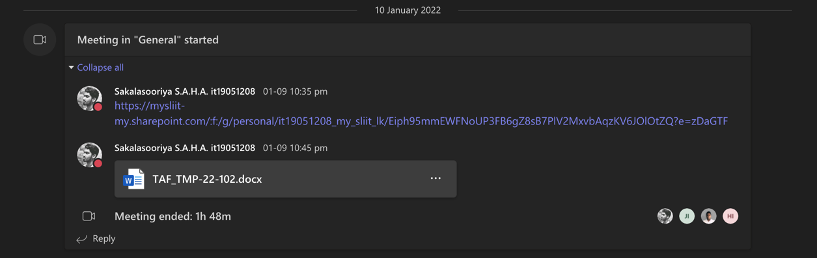

Figure 1.1. . Topic assessment form preparation discussion meeting

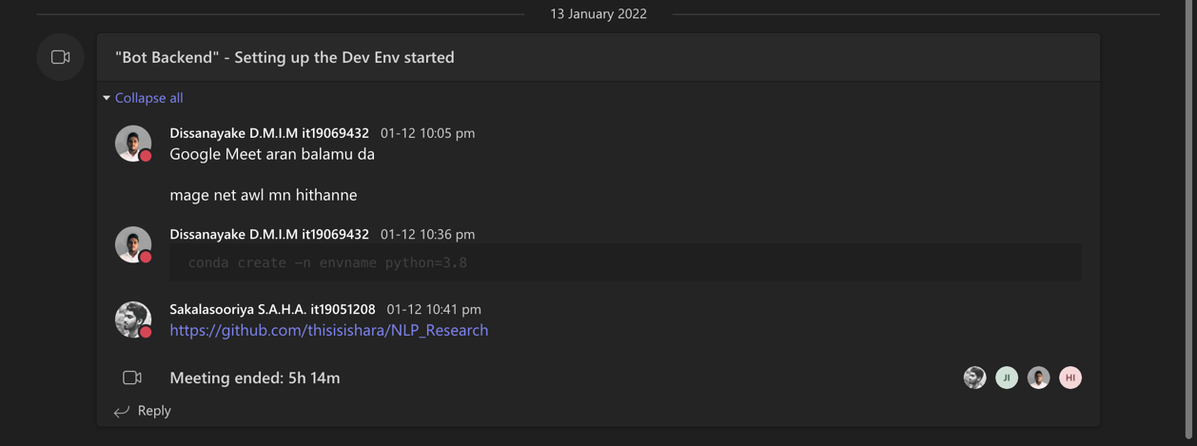

Figure 1.1. . Chatbot backend design planning meeting

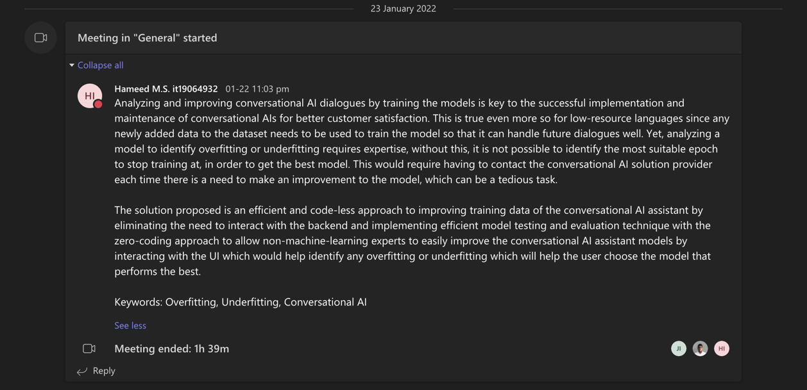

Figure 1.1. . Charter document preparation team discussion - I

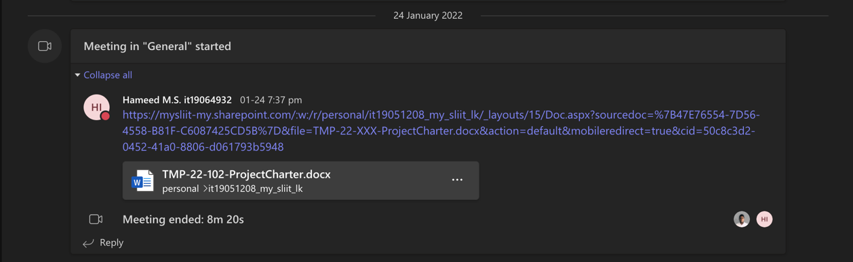

Figure 1.1. Charter document preparation team discussion - II

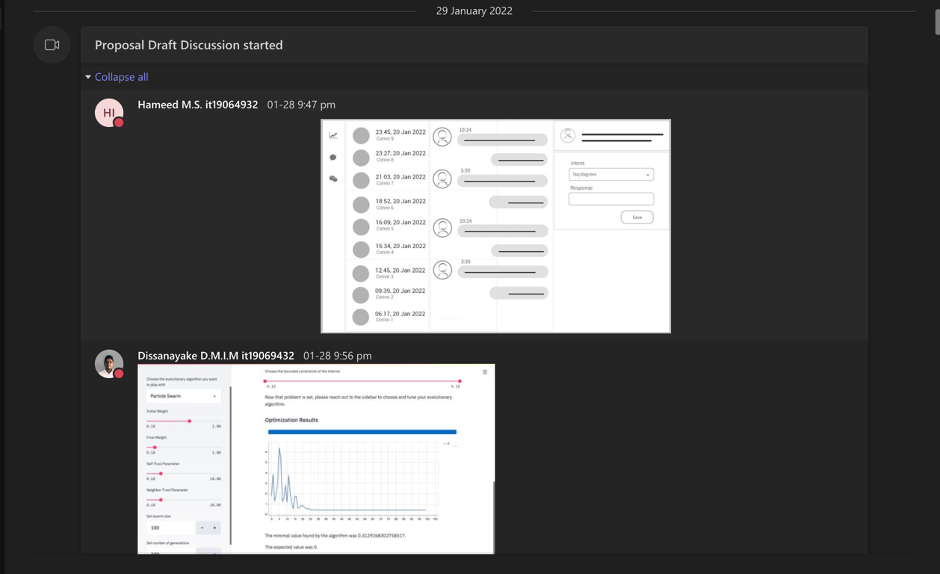

Figure 1.1. . Research proposal draft preparation discussion meeting

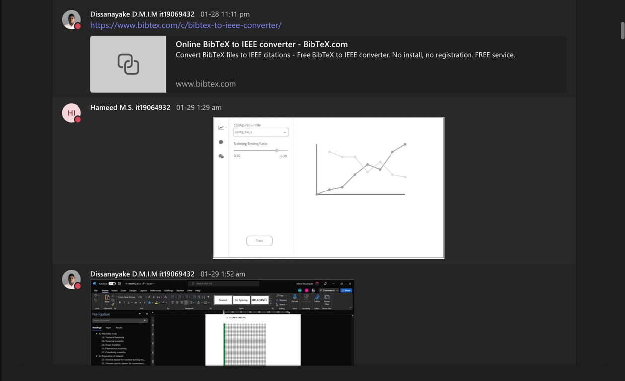

Figure 1.1. Files shared during the project proposal draft meeting - I

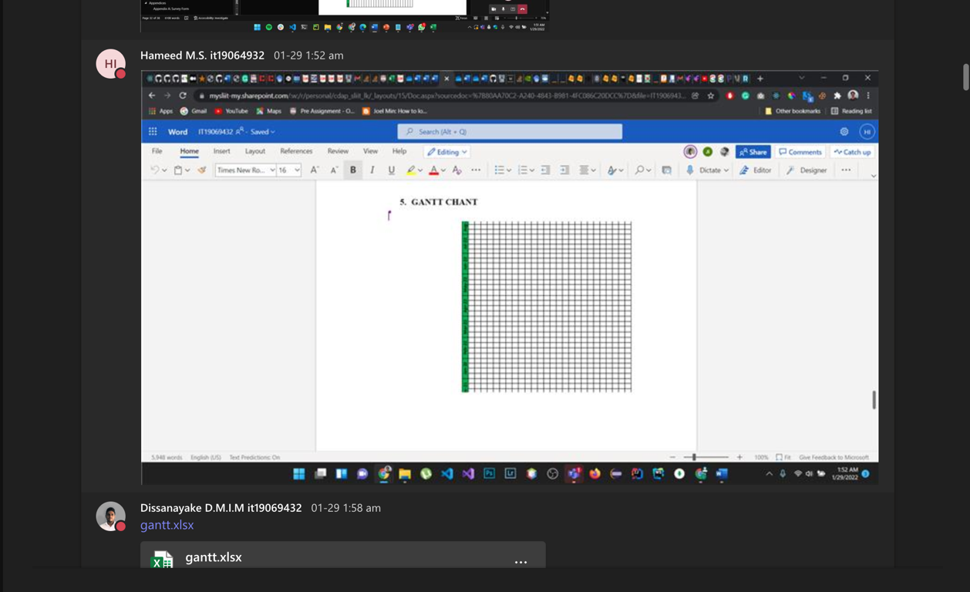

Figure 1.1. Gantt chart designed during the proposal draft discussion meeting - I

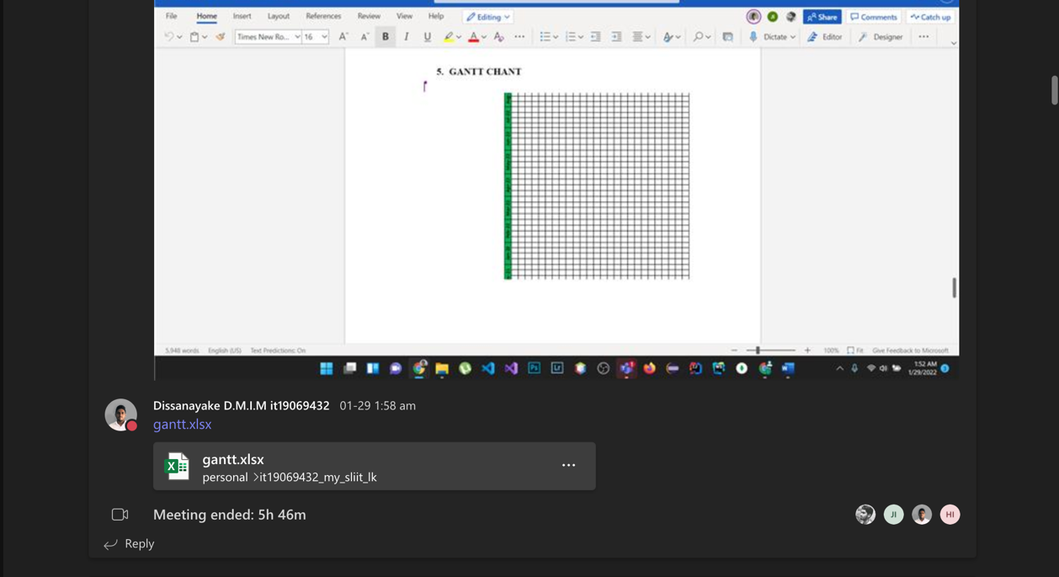

Figure 1.1. Gantt chart designed during the proposal draft discussion meeting - II

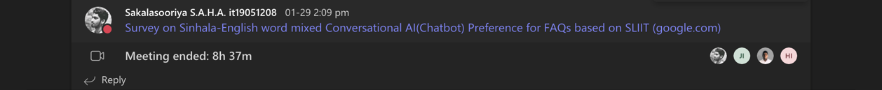

Figure 1.1. Survey planning and designing meeting

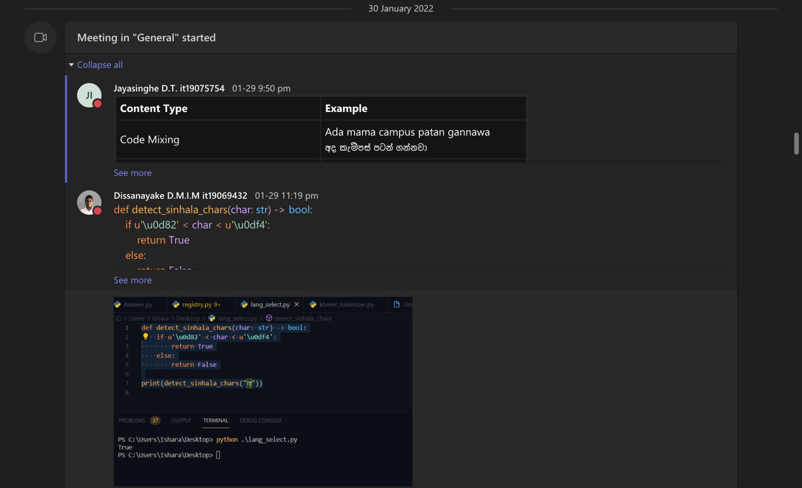

Figure 1.1. Files shared during the project proposal draft meeting - II

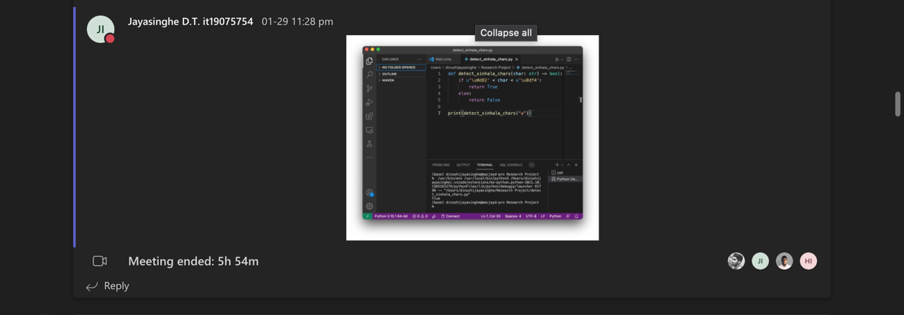

Figure 1.1. Files shared during the project proposal draft meeting - III

Figure 1.1. . Ideas shared during proposal presentation planning discussion - I

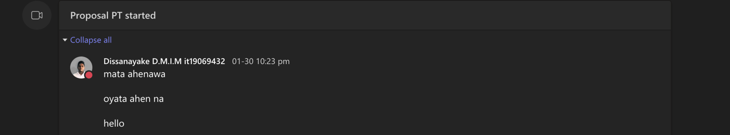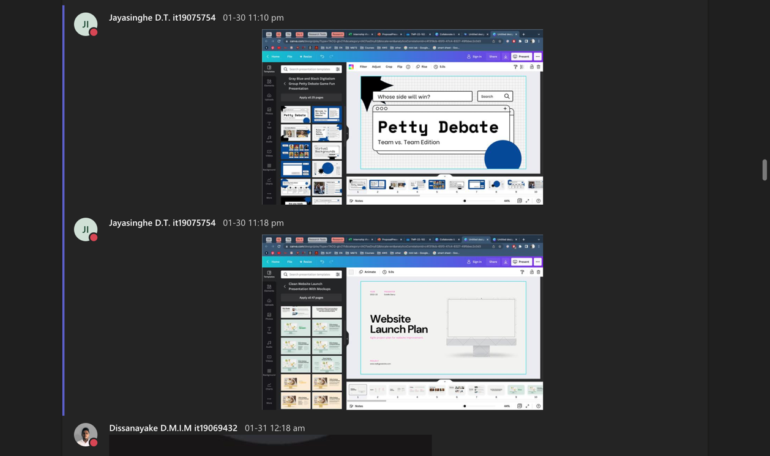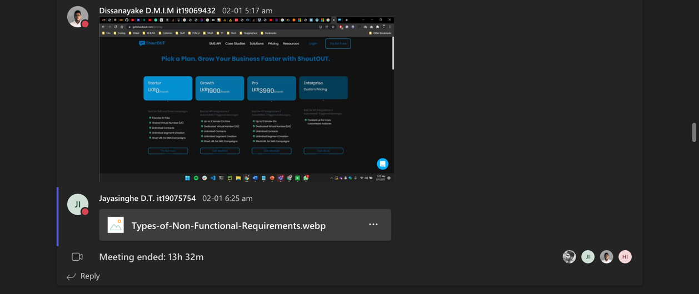

Figure 1.1. . Ideas shared during proposal presentation planning discussion - II

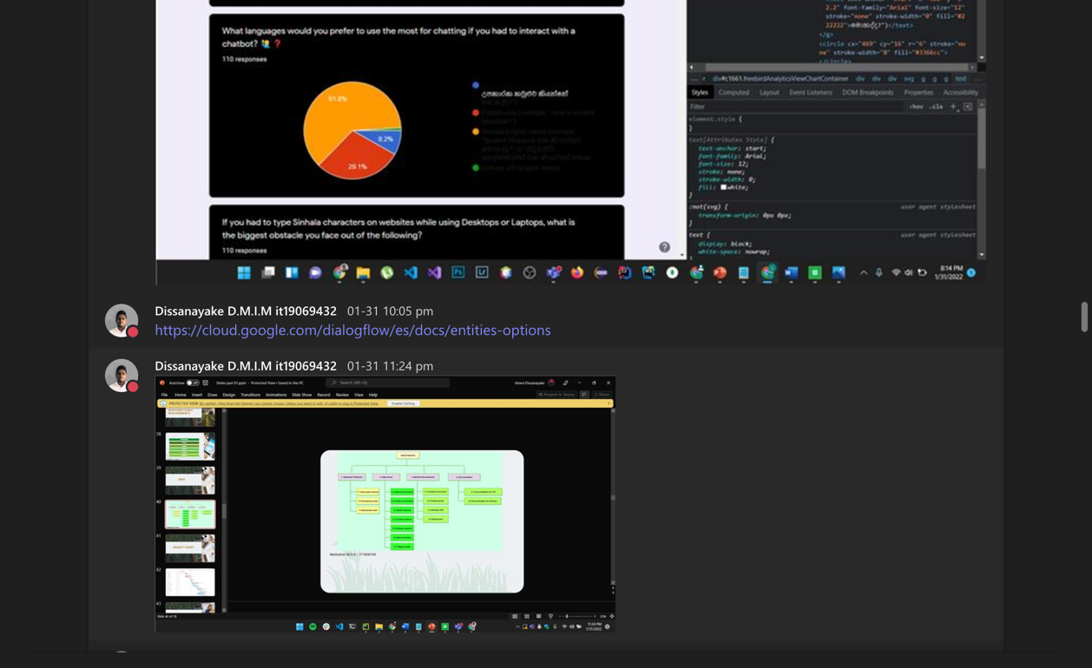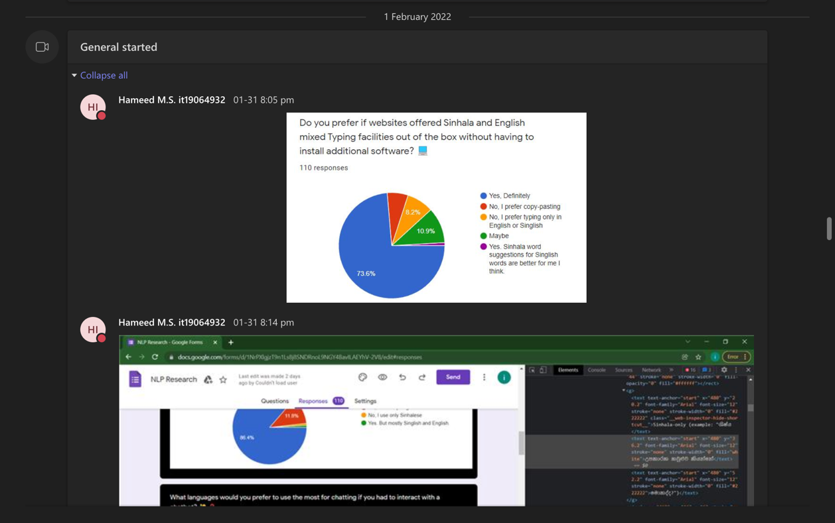

Figure 1.1. . Proposal presentation demo meeting

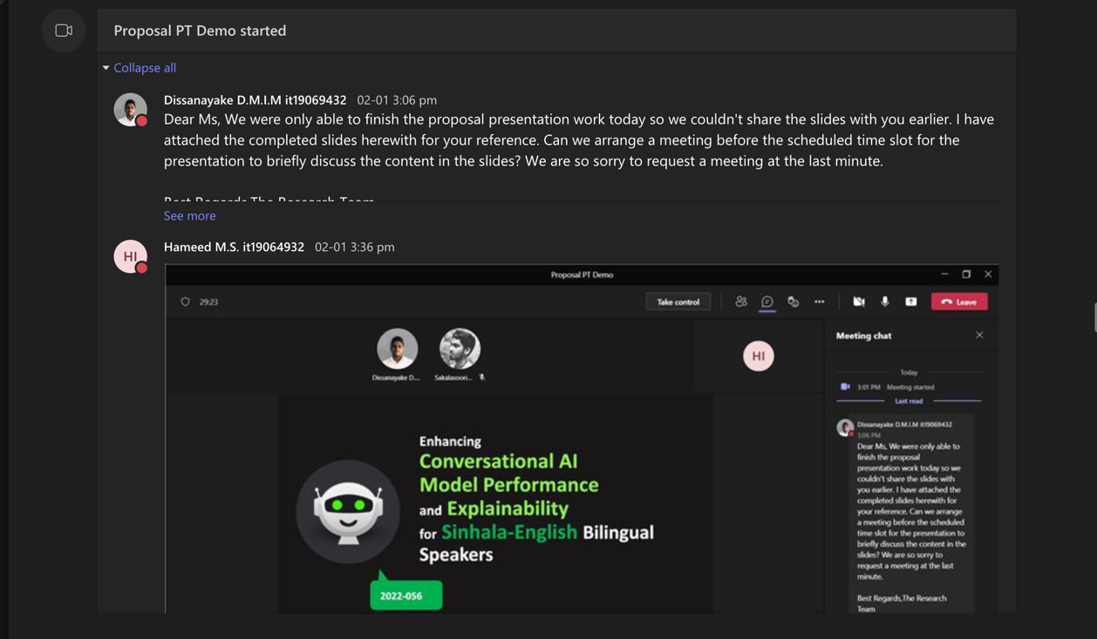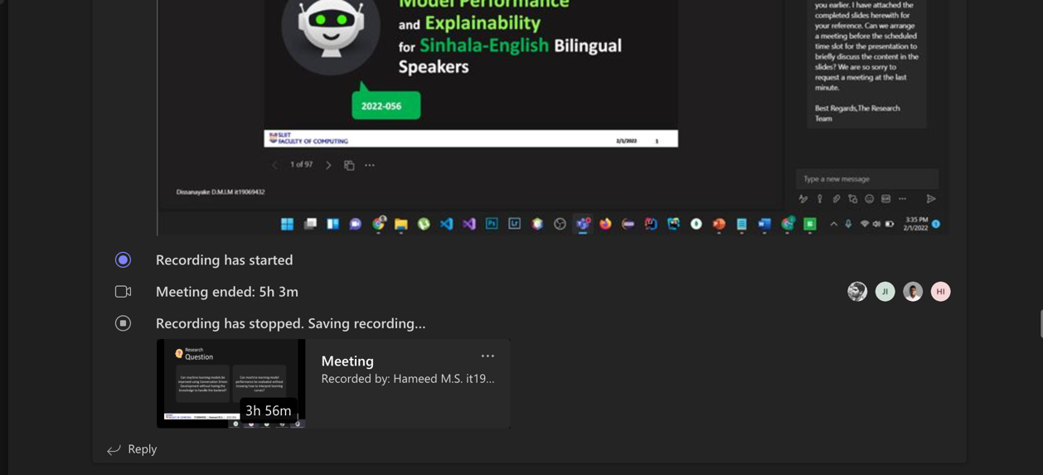

Figure 1.1. . Proposal presentation last-minute preparation meetings

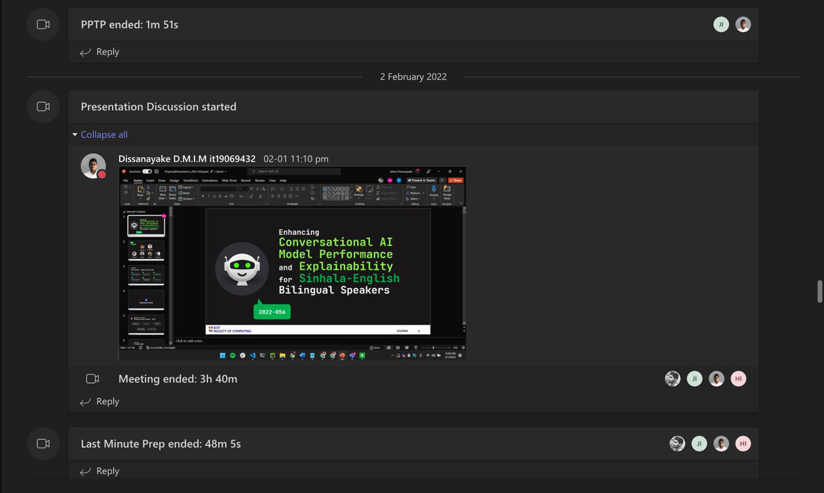

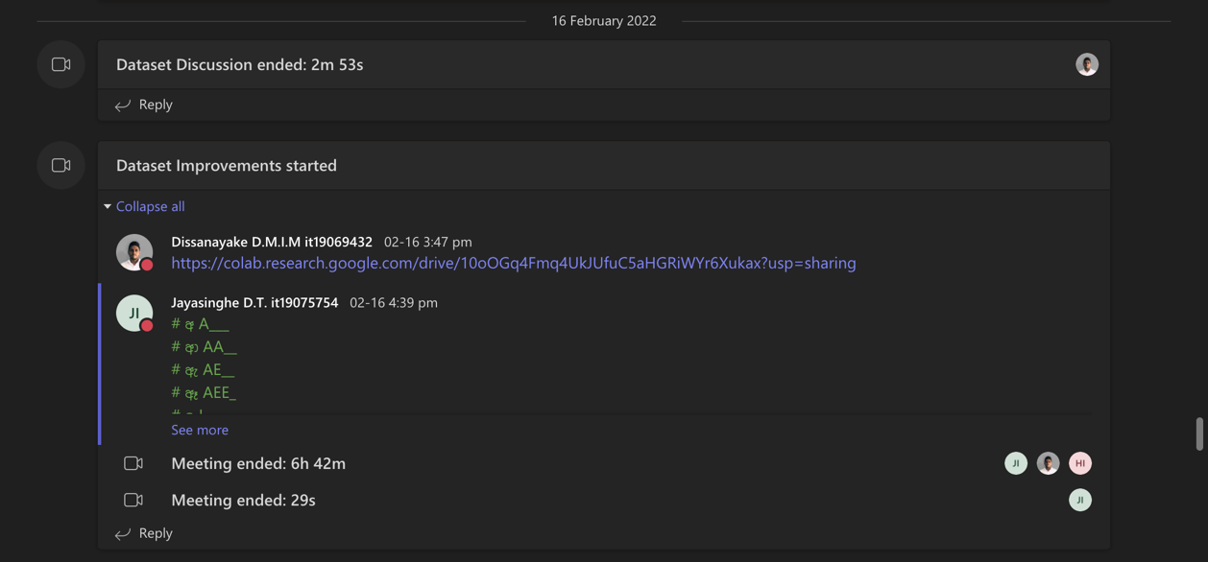

Figure 1.1. . Initial dataset preparation planning discussion meeting

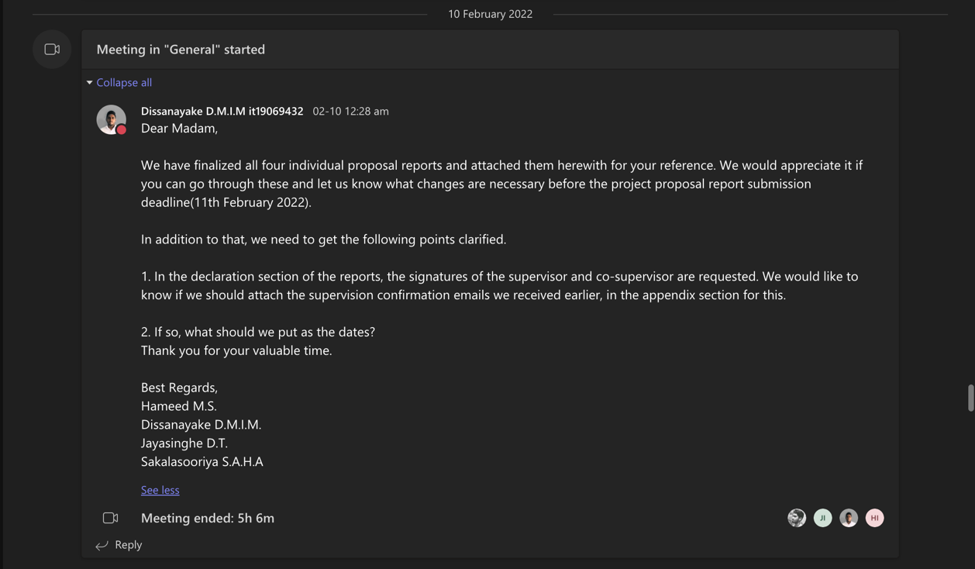

Figure 1.1. . Proposal draft submission finalization meeting

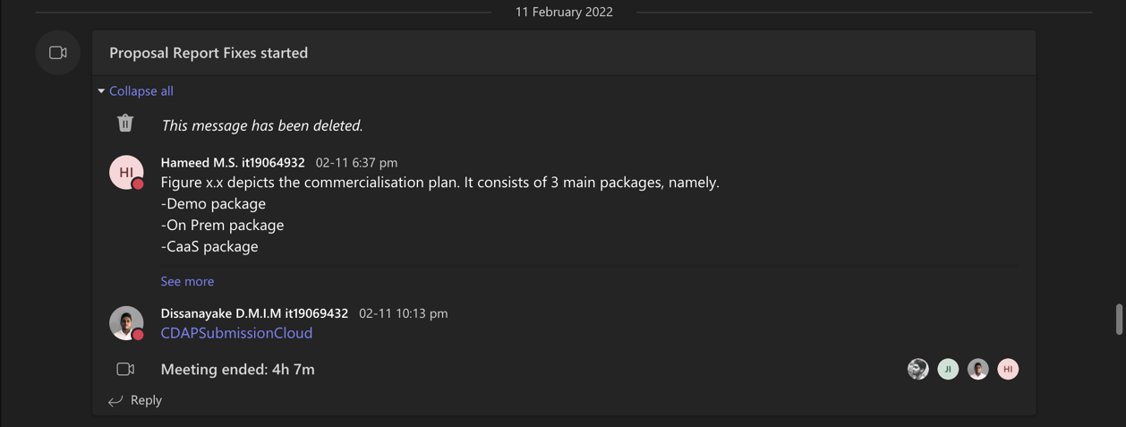

Figure 1.1. . Proposal draft review and proofreading discussion

Figure 1.1. GitLab repository setting up meeting

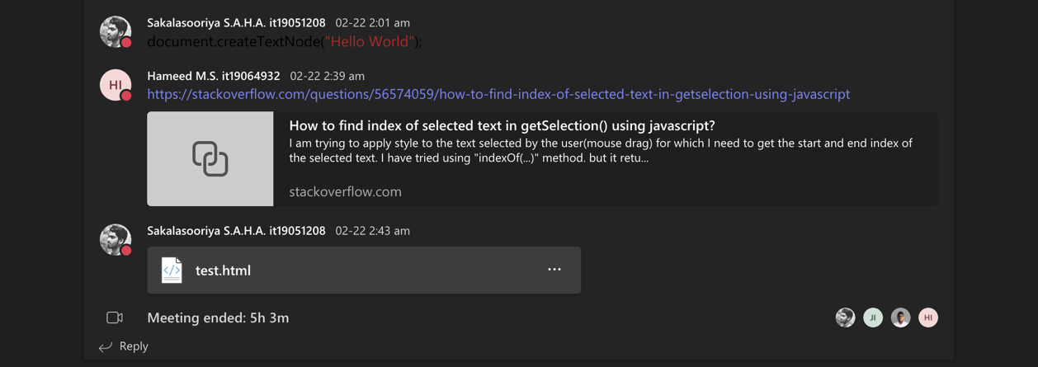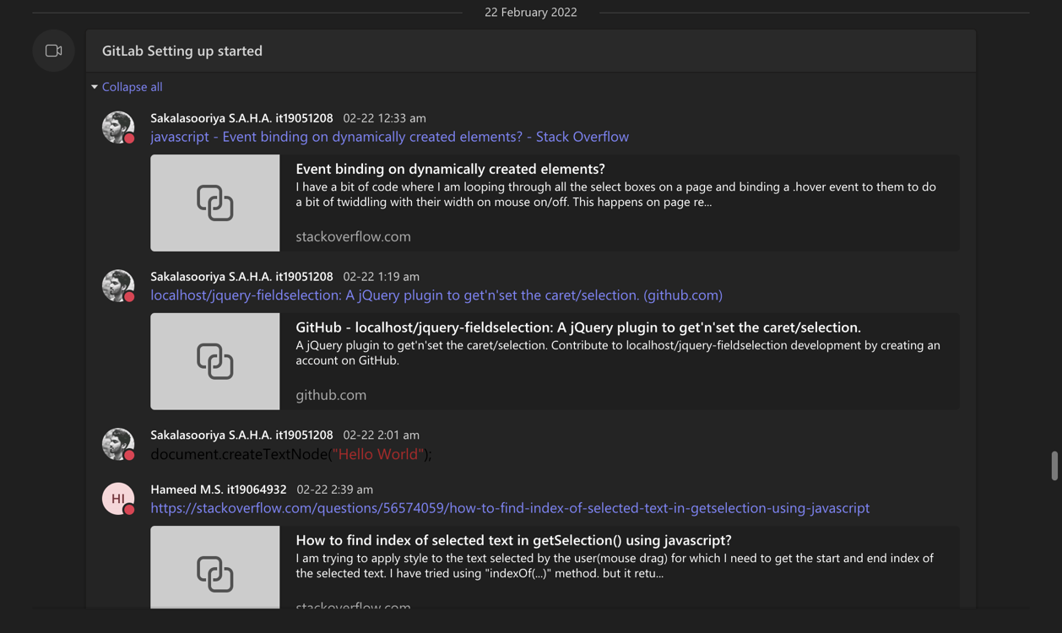

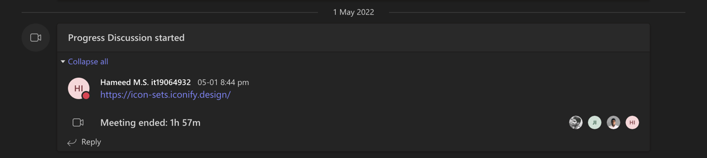

Figure 1.1. . Research 50% progress discussion meeting with the four members

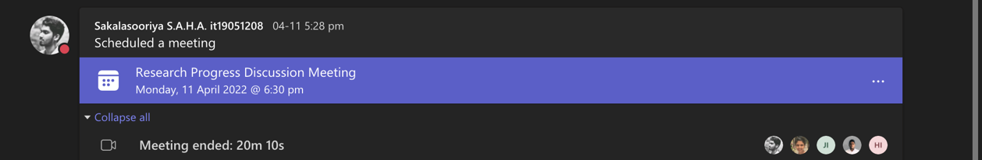

Figure 1.1. Research 50% progress discussion meeting with the team including supervisors

Individual Teams meetings

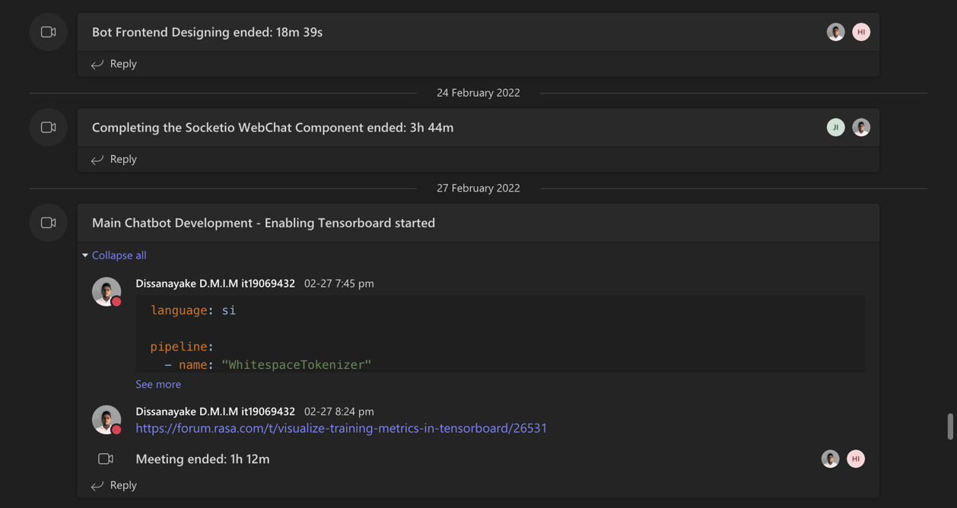Individual meetings were held to get unclear parts of the initial project development environment setup clarified. Most of the calls were taken between two to three team members.

Figure 1.1. 22. Meetings with (1) Hameed M.S. to discuss frontend design, (2) With Jayasinghe D.T. on webchat component connection, (3) With Hameed M.S. to perform TensorBoard enabling

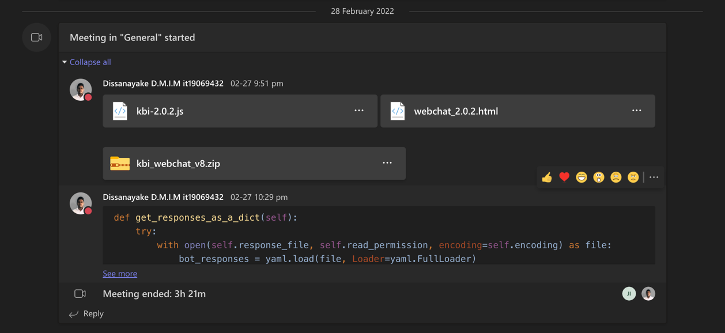

Figure 1.1. . Meeting with Jayasinghe D.T. to discuss and brainstorm on keyboard interface development process and attaching it to any website

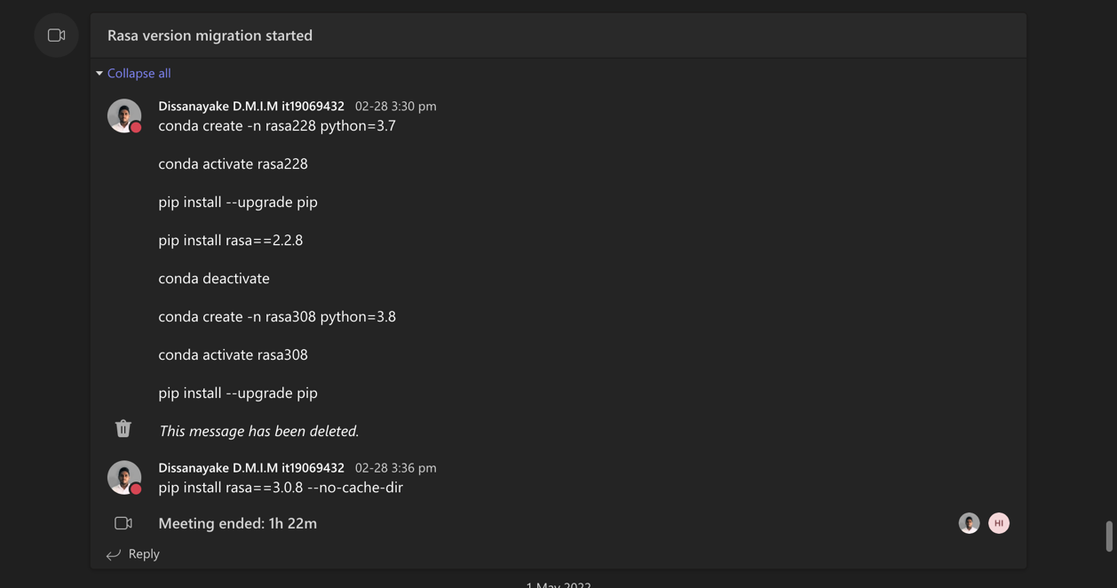

Figure 1.1. . Meeting with Hameed M.S. on Rasa version migration

## Conversations with the team

Following screenshots include all the conversations that took place via the Microsoft Teams channel, created for the Research project team.

Group conversations

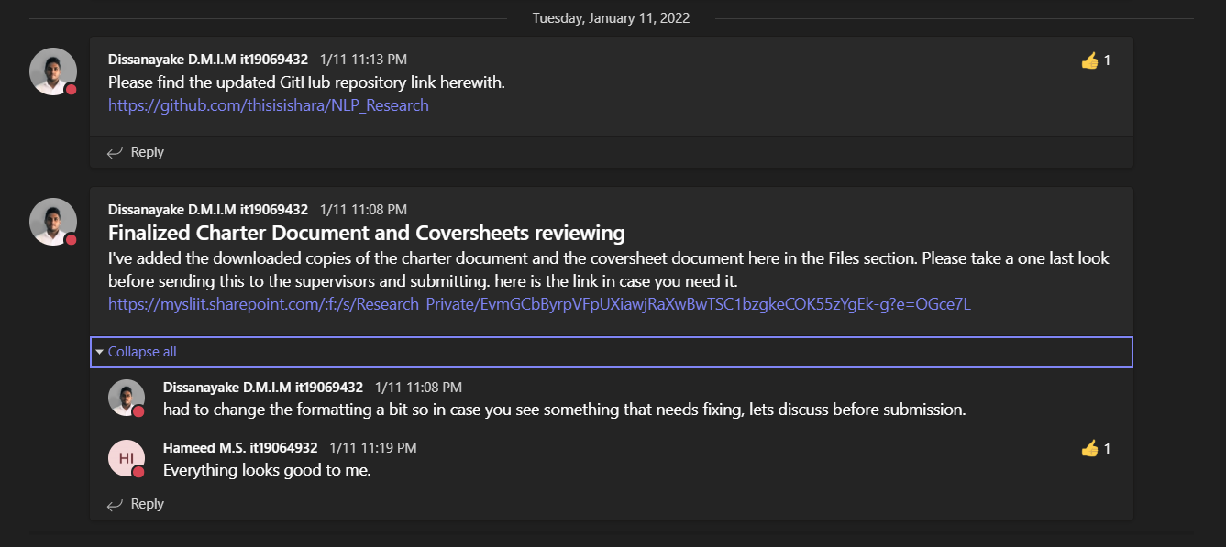

Figure 1.2. . Charter document review conversation

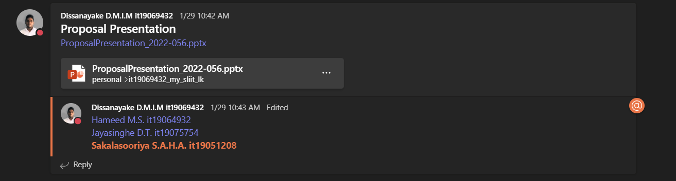

Figure 1.2. 2 Initial proposal presentation sharing and discussion

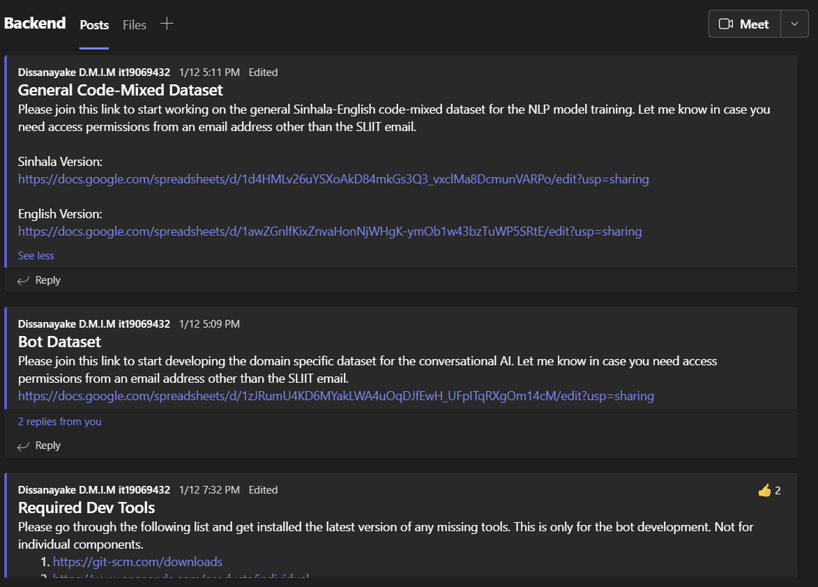

Figure 1.2. . Discussion / Resources sharing on dataset and development tools

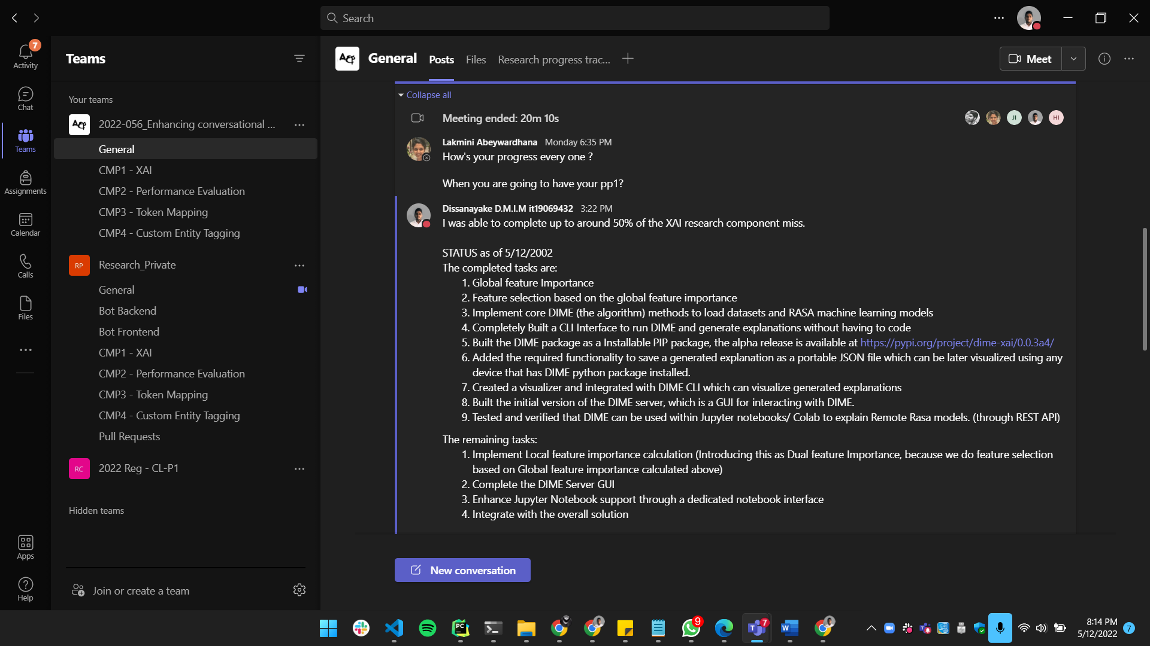Individual conversations / replies

Figure 1.2. . Project 50% status update given to supervisor

## MS Teams Planner Project Backlog

Following screenshots include all the project backlogs created using Boards in Microsoft Teams Planner.

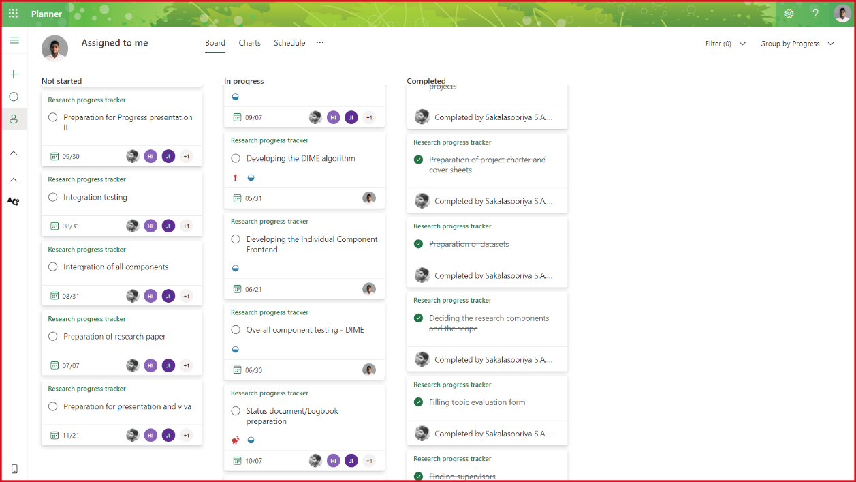

Figure 1.3. . Project backlog with individually assigned tasks to IT19069432

## MS Teams Planner Charts

Following screenshots include all the charts and other statistics generated by Microsoft Teams planner.

Group charts

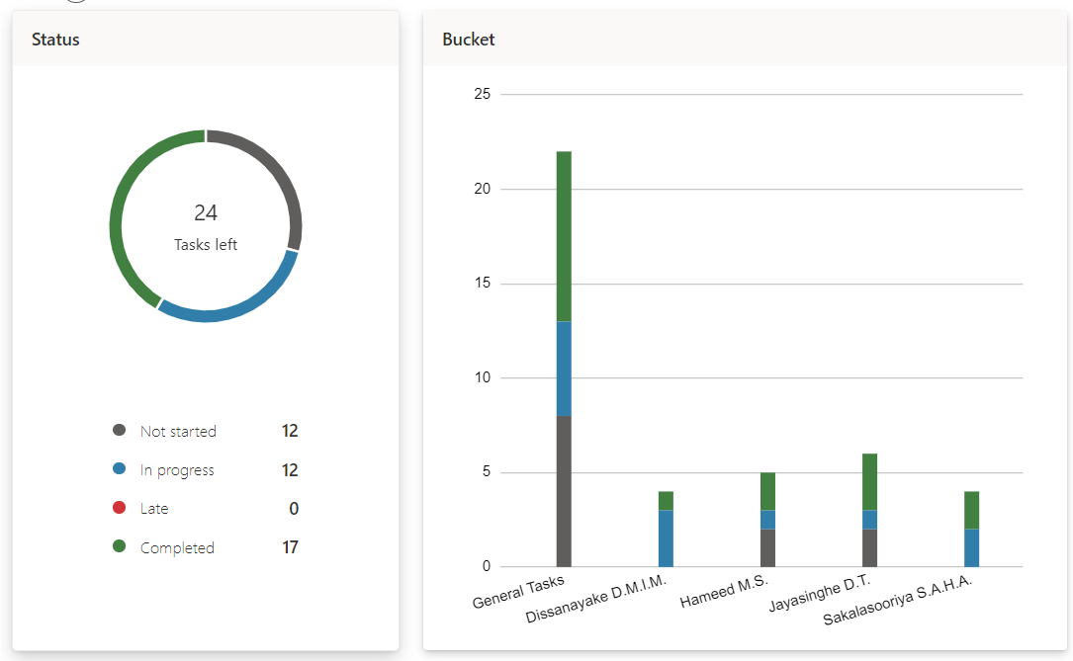

Figure 1.4. Number of total tasks and tasks assigned to each member

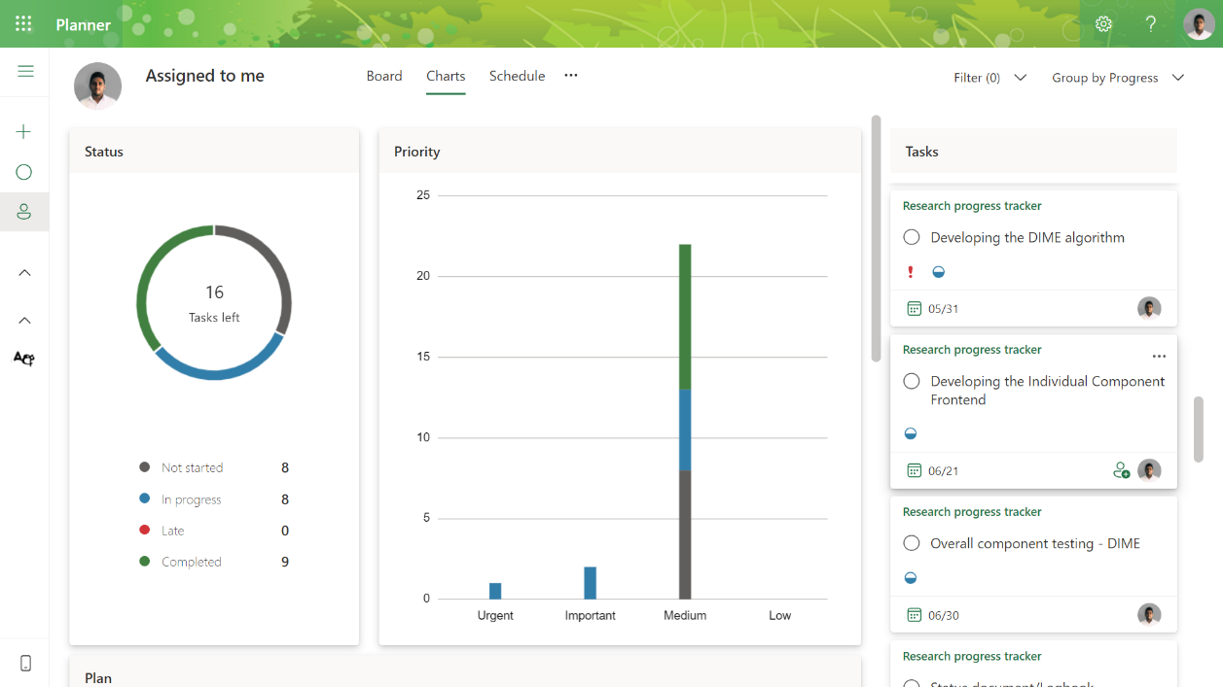Individual charts

Figure 1.4. Number of tasks assigned to IT19069432 along with priority

# Git Logs

## GitLab Branch

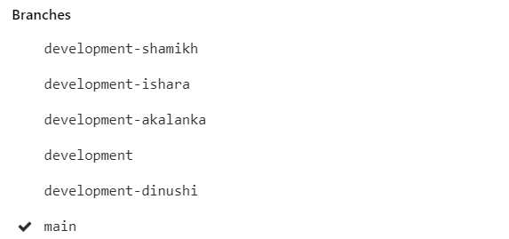The following screenshot shows the Gitlab branches created to manage each research component. All the changes will be merged into the main branch once the individual development is completed.

Figure 2.1. GitLab branches created

## GitLab Contributions

The following screenshots include latest contributions done on Gitlab.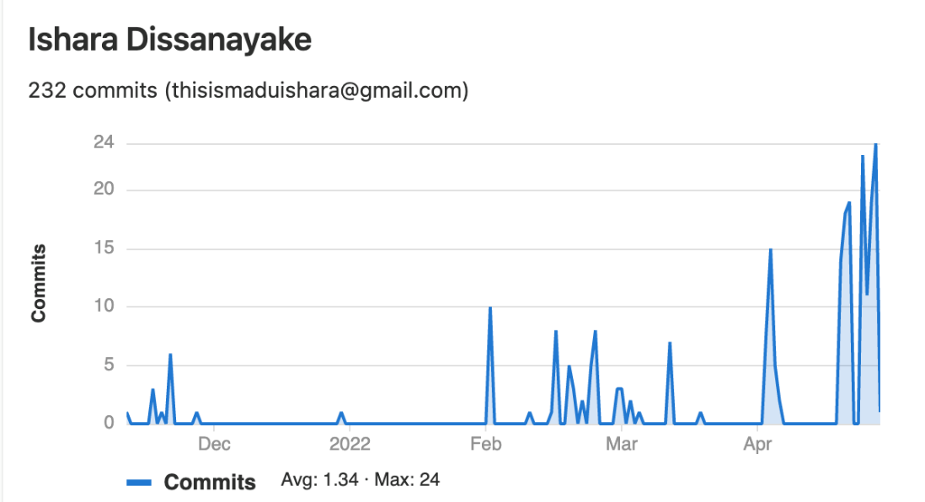

Figure 2.2. . GitLab commits overtime

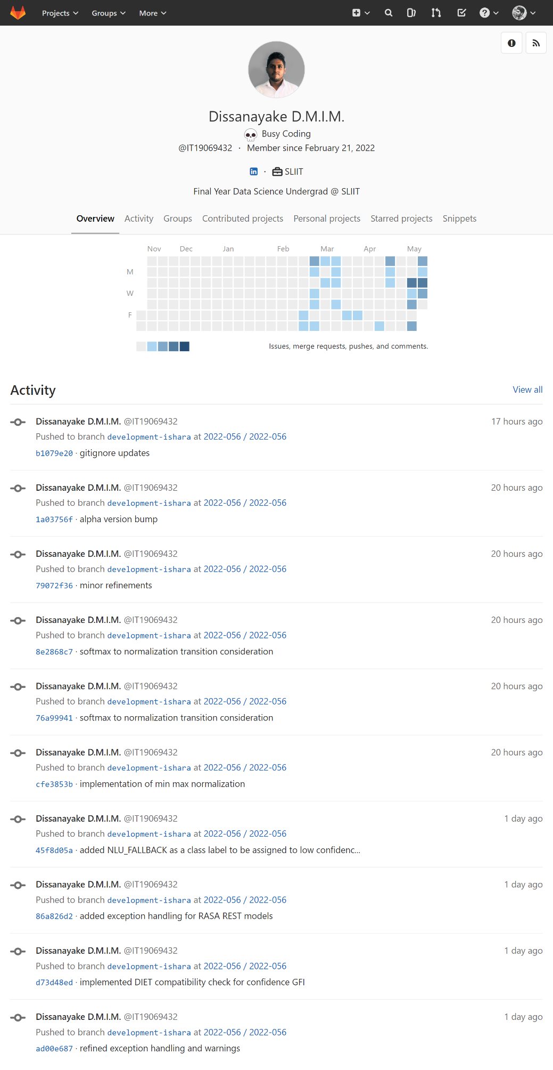

Figure 2.2. GitLab recent activity

## Individual GitHub Repositories

The following screenshots include some of the contributions done on GitHub.

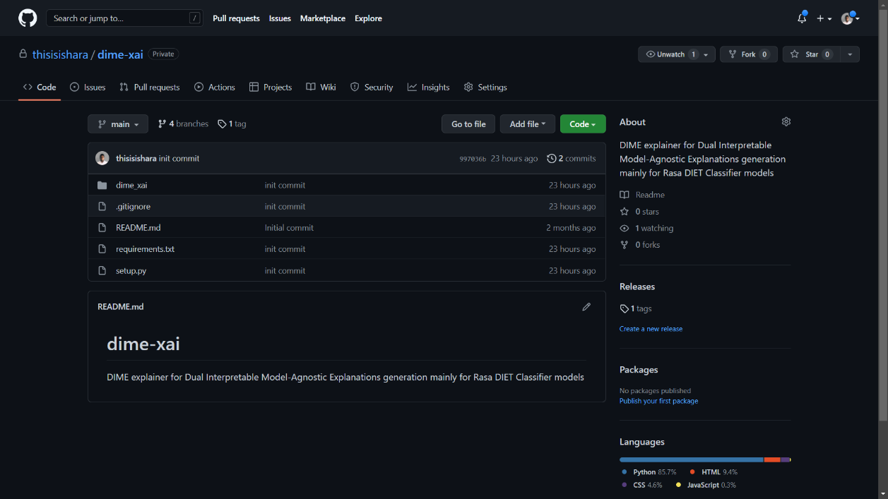

Figure 2.3. Separately maintained GitHub repository to manage DIME versioning at <https://github.com/thisisishara/dime-xai>

The reason to create a separate GitHub repository is that it allows to manage versioning of the individual research components as they yield a individually installable/usable solutions which needs to be versioned and released separately prior to uploading to any package management repository such as PyPI.

# Emails

The following screenshots include some of the emails sent to the supervisors in charge.

## Supervision requesting and confirmation emails

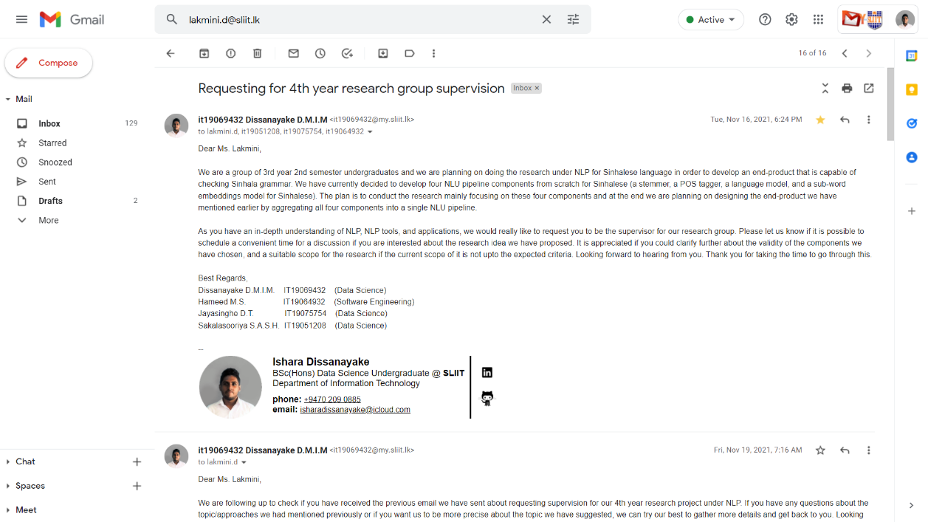

Figure 3.1. . Research supervision request email

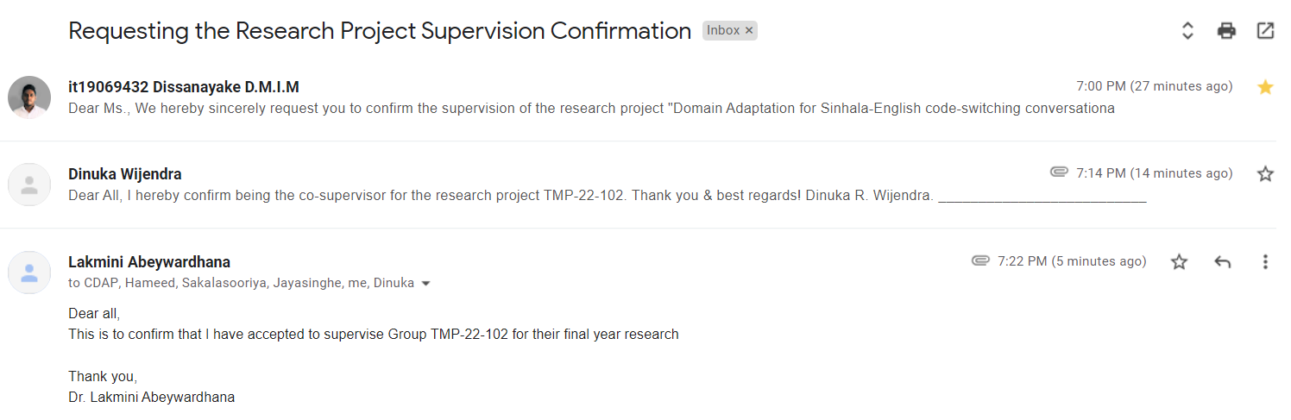

Figure 3.1. . Research project supervision confirmation

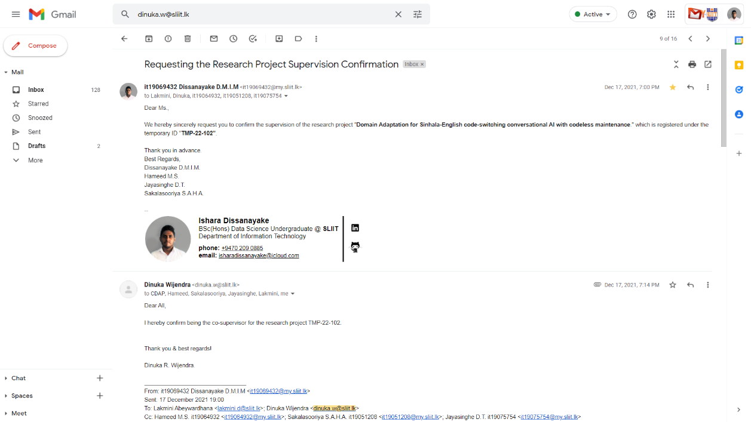

Figure 3.1. Research project co-supervision request and response

## Topic discussion meeting scheduling

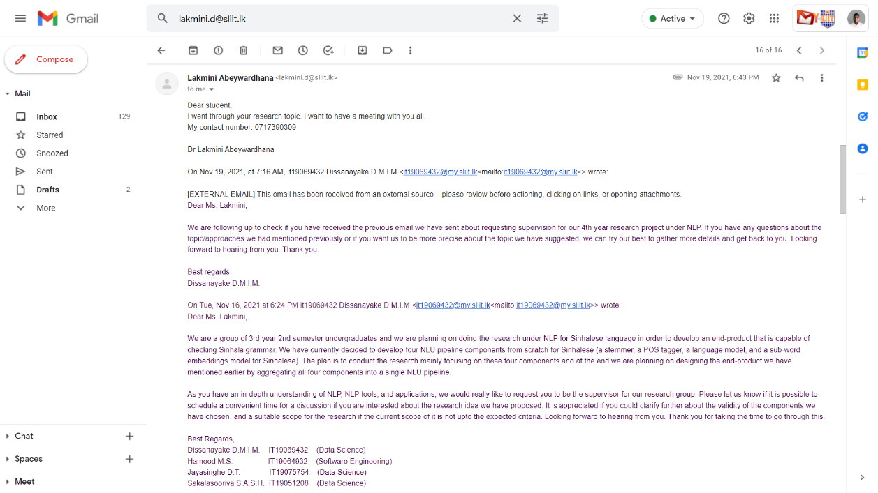

Figure 3.2. . Topic discussion meeting scheduling - I

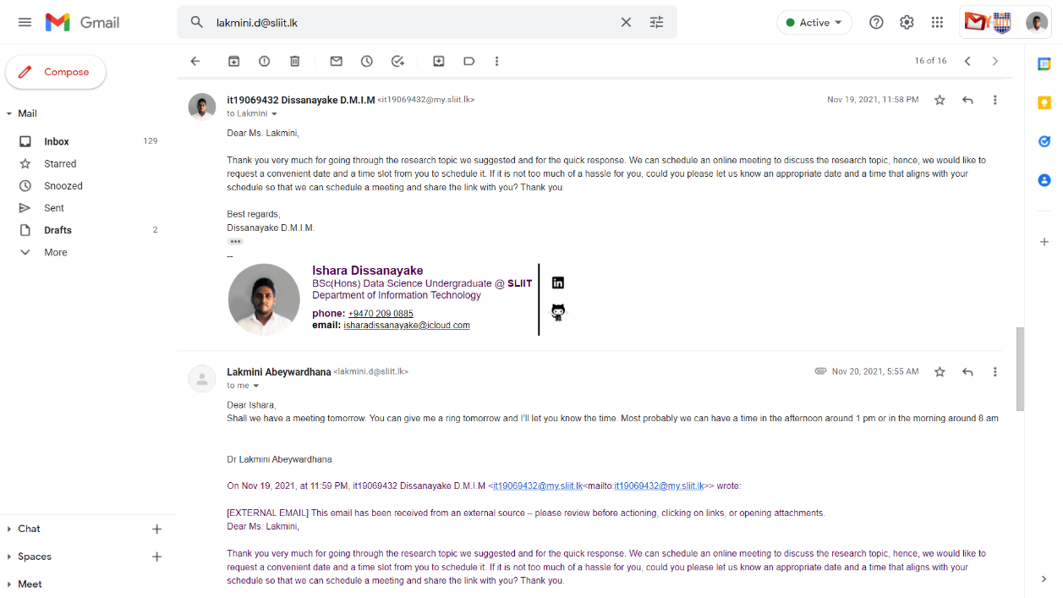

Figure 3.2. Topic discussion meeting scheduling - II

## Research proposal draft review requesting emails

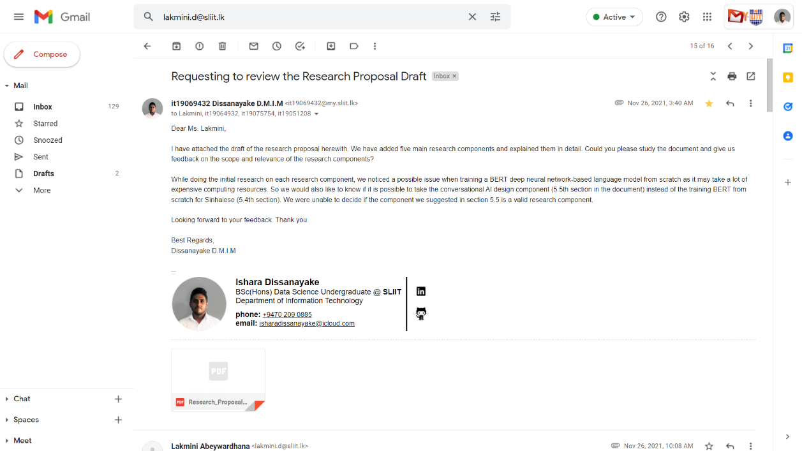

Figure 3.3. . Proposal drafts review request

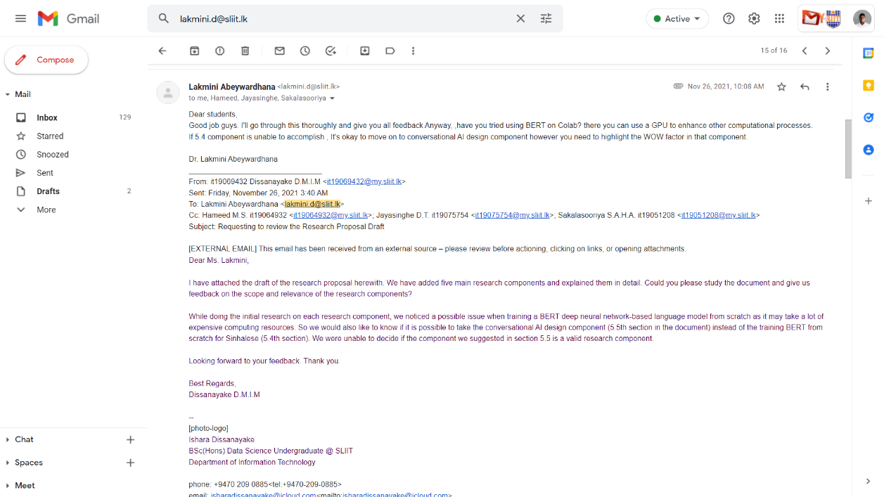

Figure 3.3. . Reply of the supervisor on proposal drafts review request

## Progress discussion meeting scheduling

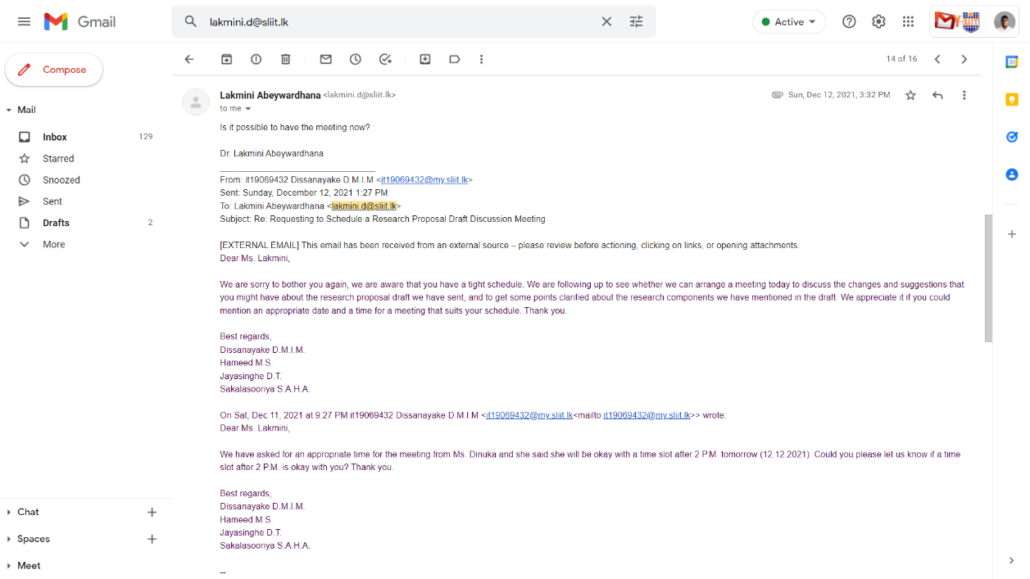

Figure 3.4. . Research progress discussion meeting request

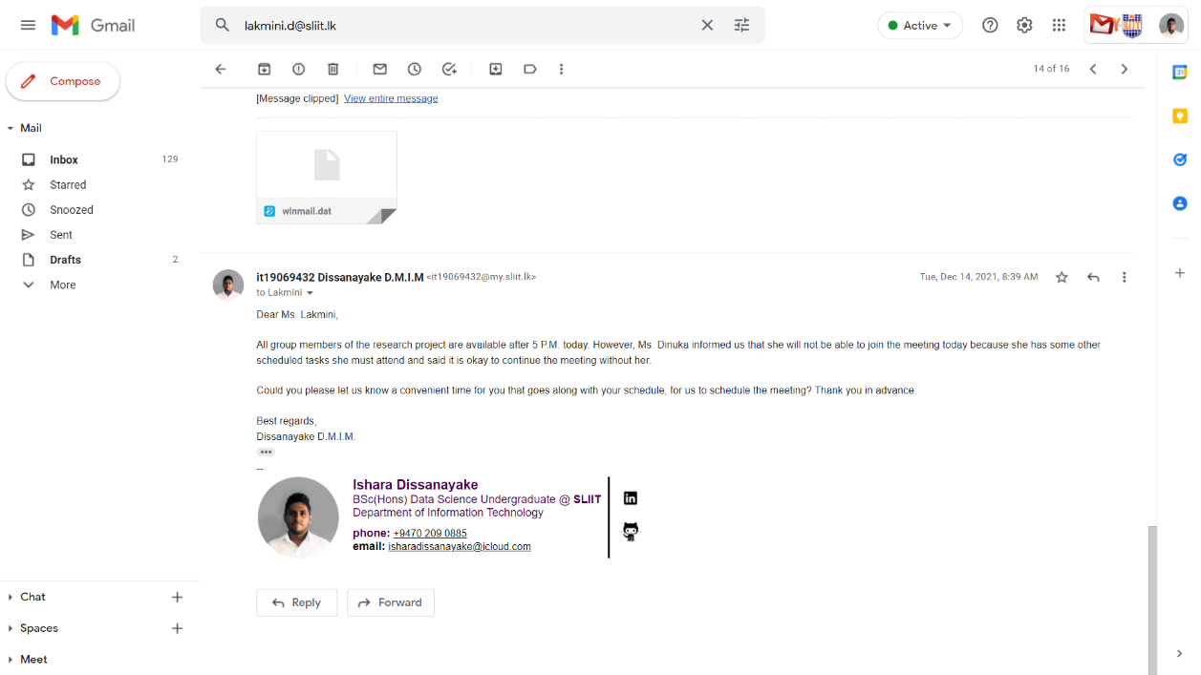

Figure 3.4. . Reply for the research progress discussion meeting request

## Topic assessments form review request

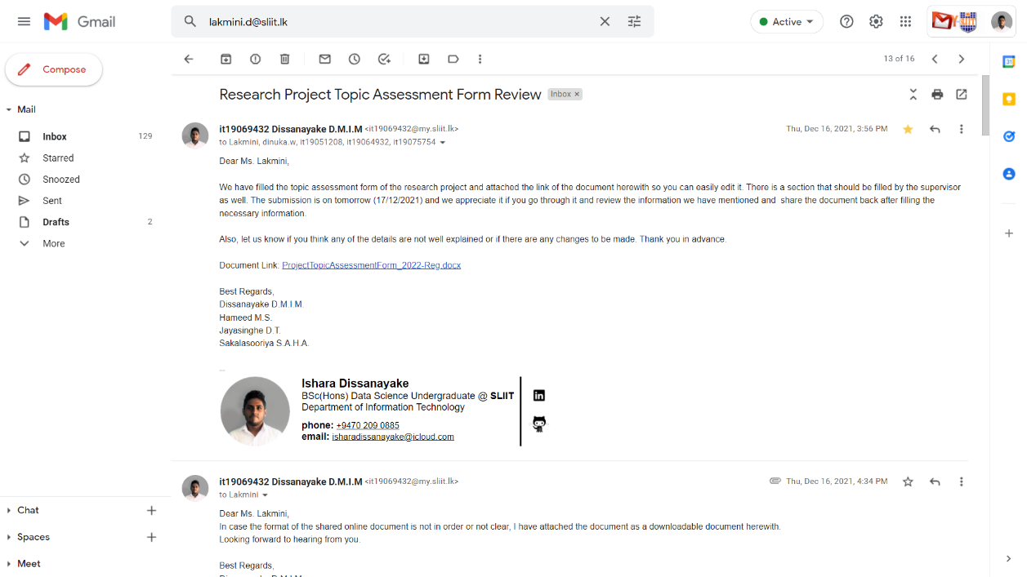

Figure 3.5. . Topic assessment form review request - I

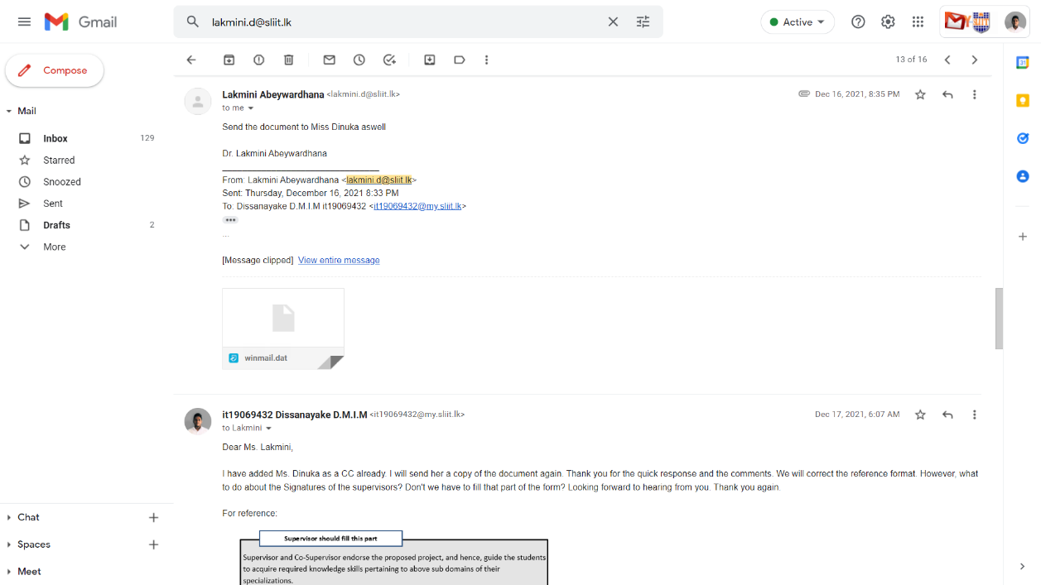

Figure 3.5. . Topic assessment form review -II

## Research component changes review request

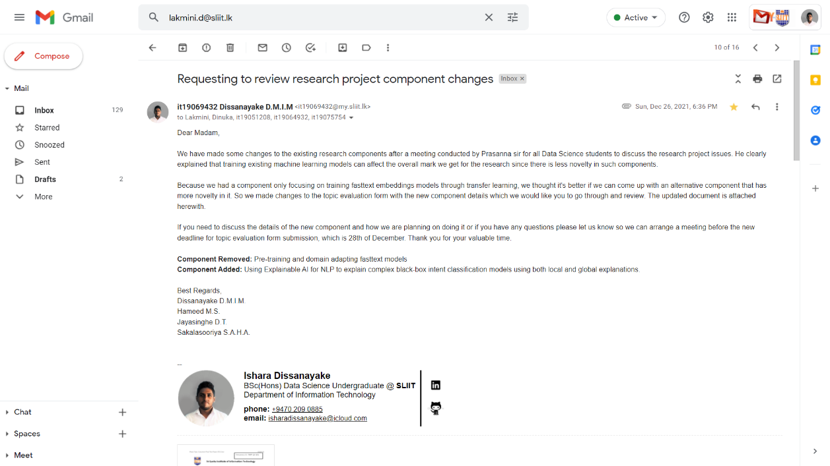

Figure 3.6. . Research component/component objective changes review request

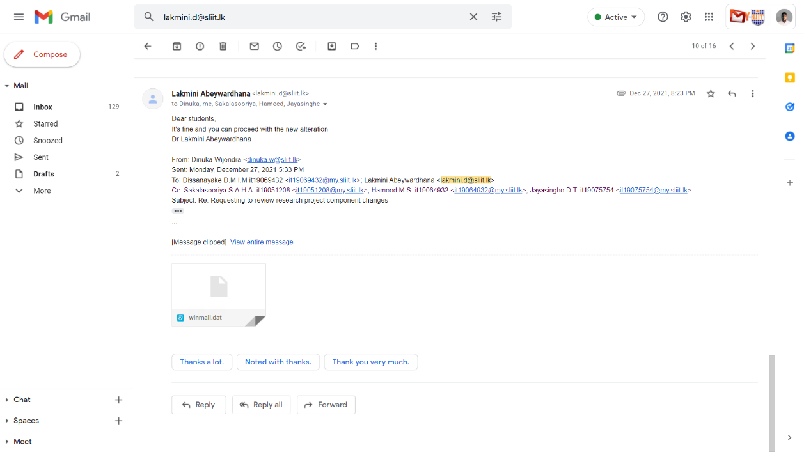

Figure 3.6. . Component changes approval of the supervisor

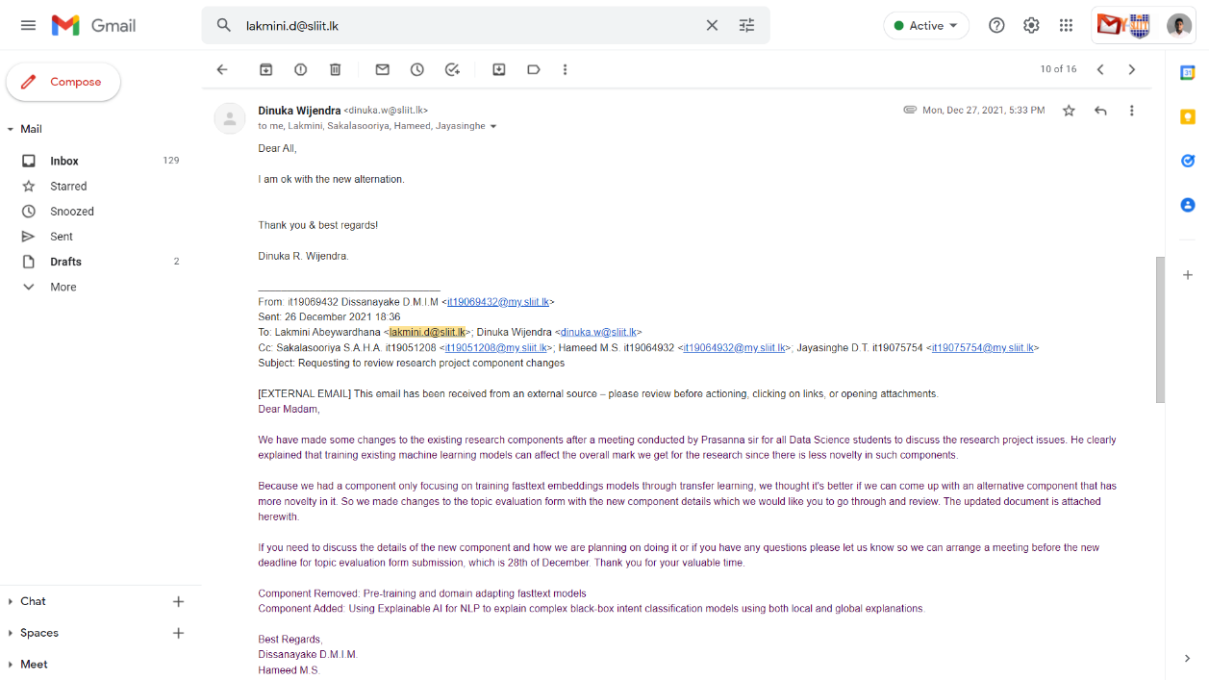

Figure 3.6. 3. Component changes approval of the co-supervisor

## Topic changes review request after panel evaluation was done

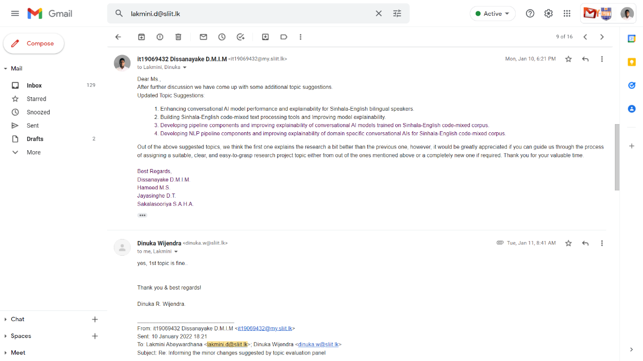

Figure 3.7. . Topics suggested by the members due to the suggestion made by the panel

## Individual project proposal documents review request

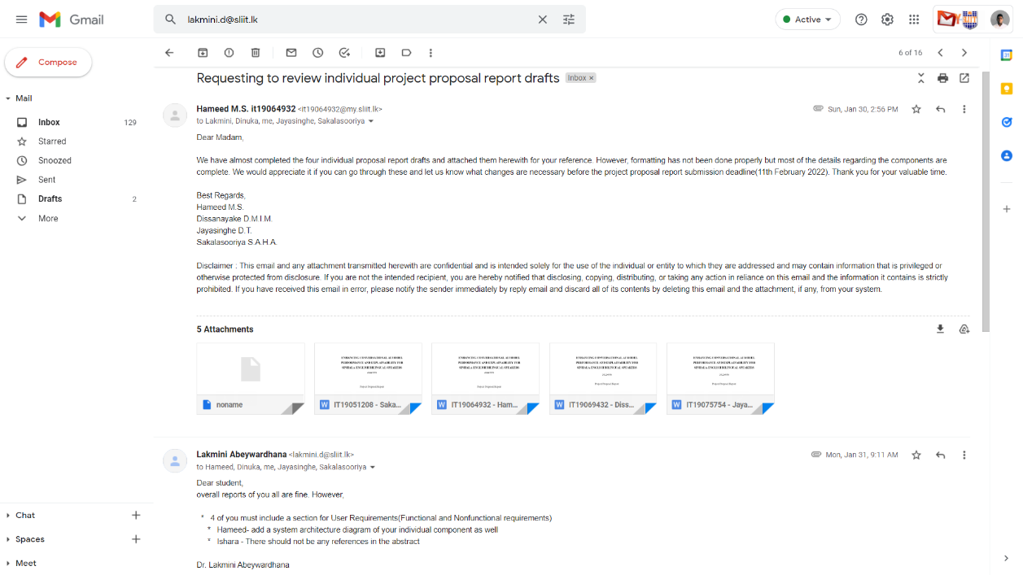

Figure 3.8. . Individual proposal draft review request

## Sharing the updated proposal presentation slides deck

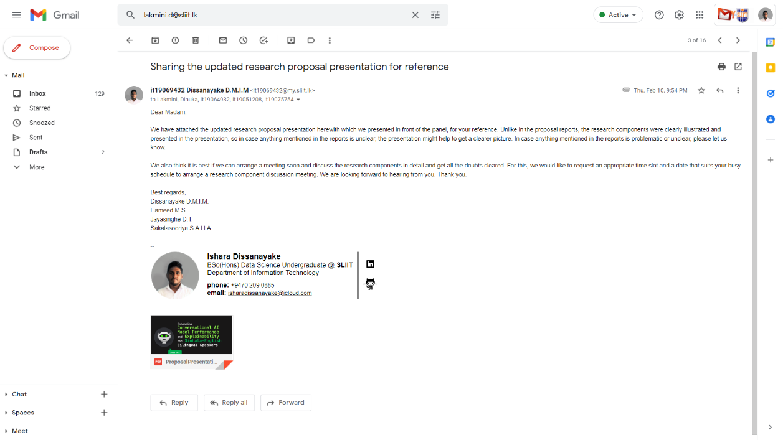

Figure 3.9. . Sharing the updated proposal slides deck

## Research progress discussion meeting before progress presentation – I

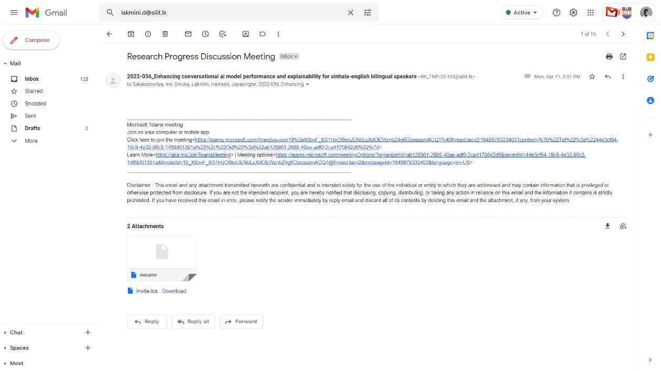

Figure 3.10. . 50% progress discussion meeting scheduling

# Gantt chart comparison

Figure 4.1 breaks down all tasks of this individual research component under 5 main tasks.

Figure 4. . Predicted Gantt chart vs actual completion comparison

Legend: ■ Predicted ■ Actual ■ Remaining­­­­­



# Work breakdown chart with pending tasks

The Figure 5.1 indicates the complete work breakdown of the individual research component and the tasks already completed have been clearly indicated with a tick.

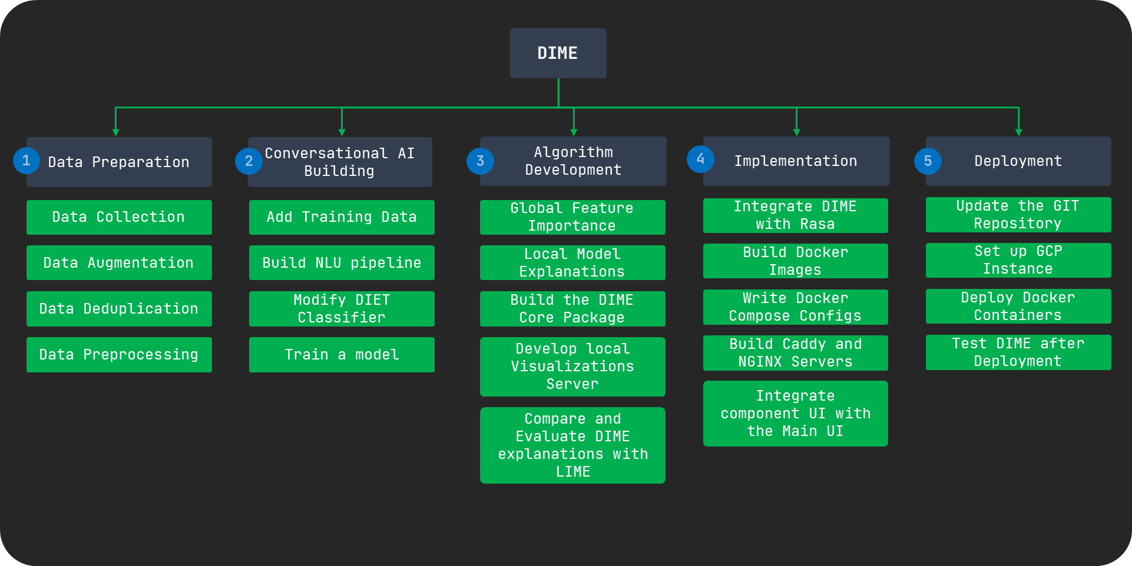­

Pending

On-going

Completed

Figure 5. . Work breakdown and Task Status of the individual component